## Merchandising use case diagrams and description

### Quotation Process:

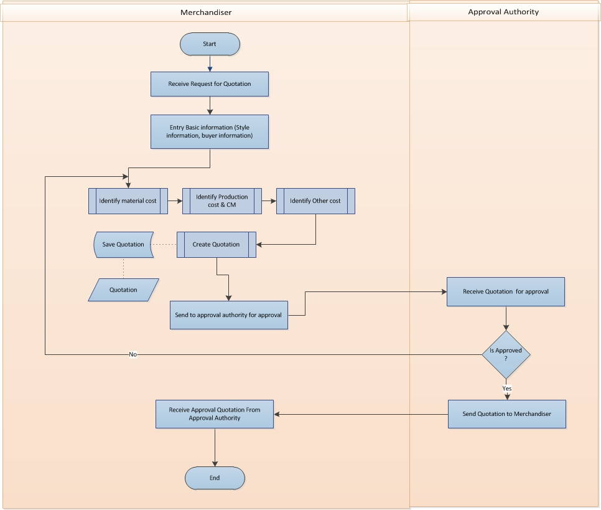

Fig: Quotation Process

|  |  |  |
| --- | --- | --- |
| Use Case ID: UCD/Mer/001 | | |
| Use Case Name**: Request Quotation** | | |
| Created By: **GenWeb2 Ltd.** | | Date Created: **10 September 2015** |
| Actors: | * Merchandiser, Buyer | |
| Trigger: | * When Buyer ask the Quotation of any style | |
| Business Rule | * Acknowledging Quotation request from Buyer | |
| Description: | 1. Buyer request to Merchandiser for Quotation 2. Merchandiser receive request for Quotation from Buyer | |
| Frequency of Use | * High | |
| Preconditions | * Defining Style * Tech pack details | |
| Post conditions | * Identifying the cost | |
| Assumption | * Already in practice | |
| Goal | * Acknowledging request | |
| Normal Flow | * Buyer request to Merchandiser for Quotation * Merchandiser receive request for Quotation from Buyer | |
| Alternate Flow | * N/A | |
| Exception | * Cancel request | |
| Cross Reference | * N/A | |

|  |  |  |
| --- | --- | --- |
| Use Case ID: UCD/Mer/002 | | |
| Use Case Name**: Identify Costs** | | |
| Created By: **GenWeb2 Ltd.** | | Date Created: **10 September 2015** |
| Actors: | * Merchandiser | |
| Trigger: | * When Merchandiser receive the request for Quotation | |
| Business Rule | * Pre cost calculation and Quotation finalization | |
| Description: | 1. Based on style and tech pack Merchandiser identify the cost 2. Merchandiser goes for every single elements to calculate the costing along with CM and Profit margin 3. Prepare quotation | |
| Frequency of Use | * High | |
| Preconditions | * Defining Style * Quotation request from buyer | |
| Post conditions | * Quotation Approval | |
| Assumption | * Already in practice | |
| Goal | * Prepare Quotation | |
| Normal Flow | * Merchandiser receive style from buyer * Based on style and tech pack Merchandiser identify the cost of every element like material cost, other cost and CM * Prepare quotation | |
| Alternate Flow | * N/A | |
| Exception | * N/A | |
| Cross Reference | * N/A | |

|  |  |  |
| --- | --- | --- |
| Use Case ID: UCD/Mer/003 | | |
| Use Case Name**: Approve Quotation** | | |
| Created By: **GenWeb2 Ltd.** | | Date Created: **10 September 2015** |
| Actors: | * Merchandiser, Approval Authority | |
| Trigger: | * When Merchandiser prepare Quotation | |
| Business Rule | * Approve Quotation | |
| Description: | 1. After Prepare quotation, Merchandiser sent quotation to approval authority for approval 2. If the quotation is approved then send back 3. If the quotation is not approved then Merchandiser modify the quotation and resubmits for approval 4. Modification process will continue until the Quotation is approved | |
| Frequency of Use | * High | |
| Preconditions | * Quotation must be exist | |
| Post conditions | * Modify Quotation (if not approved) * Submit Quotation to Buyer (if approved) | |
| Assumption | * Already in practice | |
| Goal | * Validate the Quotation by Approval Authority | |
| Normal Flow | * After Prepare quotation, Merchandiser sent quotation to approval authority for approval * Approved Quotation gets back to Merchandiser for submit to Buyer * Unapproved Quotation gets back to Merchandiser for modification and will be in approval process again. | |
| Alternate Flow | * N/A | |
| Exception | * N/A | |
| Cross Reference | * N/A | |

|  |  |  |
| --- | --- | --- |
| Use Case ID: UCD/Mer/004 | | |
| Use Case Name**: Submit Quotation** | | |
| Created By: **GenWeb2 Ltd.** | | Date Created: **10 September 2015** |
| Actors: | * Merchandiser, Buyer | |
| Trigger: | * When Approval Authority any Quotation | |
| Business Rule | * Submitting any approved Quotation to Buyer against Quotation request | |
| Description: | 1. After approved the Quotation Merchandiser submit it to Buyer | |
| Frequency of Use | * High | |
| Preconditions | * Quotation must be approved | |
| Post conditions | * Approve by Buyer | |
| Assumption | * Already in practice | |
| Goal | * Submit the Quotation against the request | |
| Normal Flow | * After approved the Quotation Merchandiser submit it to Buyer | |
| Alternate Flow | * N/A | |
| Exception | * N/A | |
| Cross Reference | * N/A | |

### Revise Quotation:

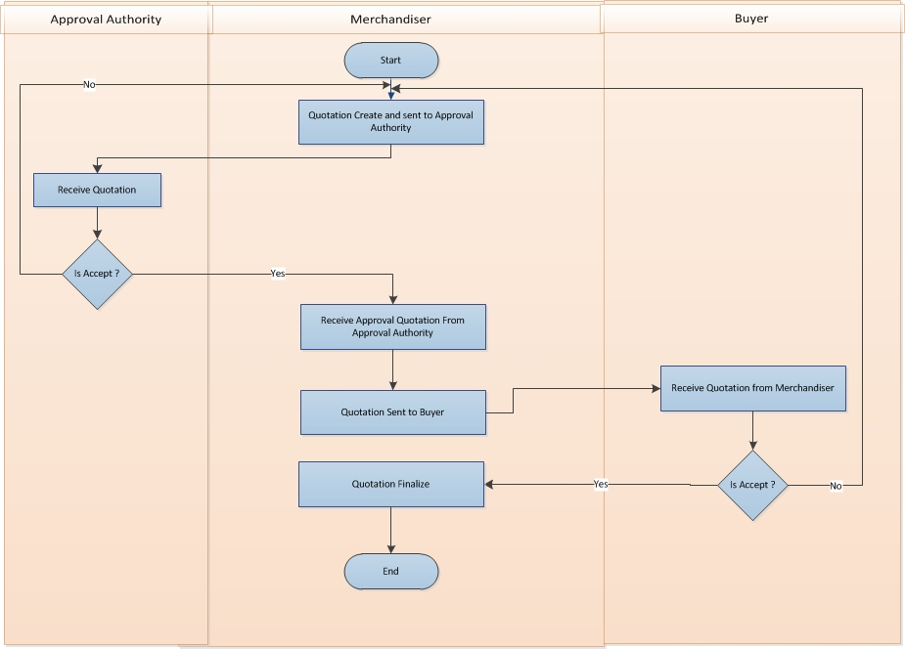

Fig: Revise Quotation

|  |  |  |
| --- | --- | --- |
| Use Case ID: UCD/Mer/005 | | |
| Use Case Name**: Revise Quotation** | | |
| Created By: **GenWeb2 Ltd.** | | Date Created: **10 September 2015** |
| Actors: | * Merchandiser, Approval Authority, Buyer | |
| Trigger: | * When Buyer ask any revision in Quotation | |
| Business Rule | * Revising the submitted Quotation | |
| 1. Description: | 1. Buyer ask any revision in Quotation 2. Merchandiser revise the Quotation and sent to Approval Authority 3. Approval Authority can accept or reject the revised Quotation 4. If Approval Authority accept this Quotation then Merchandiser submit the revised Quotation to Buyer 5. If Buyer accept this Quotation then Merchandiser finalize this Quotation 6. If Buyer not accept this Quotation then Merchandiser again revise the Quotation and sent to Approval Authority for approval 7. It will continue base accepted or not | |
| Frequency of Use | * Medium | |
| Preconditions | * Submission of Quotation | |
| Post conditions | * Order confirmation, booking or cancellation by the buyer | |
| Assumption | * Already in practice | |
| Goal | * Addressing the revision | |
| Normal Flow | * Buyer ask any revision in Quotation * Concern Merchandiser address the revision request by Buyer and send to approval authority for further approval * Approval Authority can accept or reject the revised Quotation * If Approval Authority accept this Quotation then Merchandiser submit the revised Quotation to Buyer * If Approval Authority not approve the quotation then merchandiser modify the quotation and send for approval again. * If Buyer accept this Quotation then Merchandiser finalize this Quotation * If Buyer not accept this Quotation then Merchandiser again revise the Quotation and sent to Approval Authority for approval * It may continue based on approval and revision status | |
| Alternate Flow | * N/A | |
| Exception | Quotation may be cancelled | |
| Cross Reference | * N/A | |